**Chapter 26 Check Point Questions**

**1.** What is an AVL tree? Describe the following terms: balance factor, left-heavy, and right-heavy.

AVL trees are well-balanced. In an AVL tree, the difference between the heights of two subtrees for every node is 0 or 1.

The balance factor of a node is the height of its right subtree minus the height of its left subtree. A node is said to be balanced if its balance factor is -1, 0, or 1. A node is said to be left-heavy if its balance factor is -1. A node is said to be right-heavy if its balance factor is +1.

**2**. Show the balance factor of each node in the trees shown in Figure 26.1.

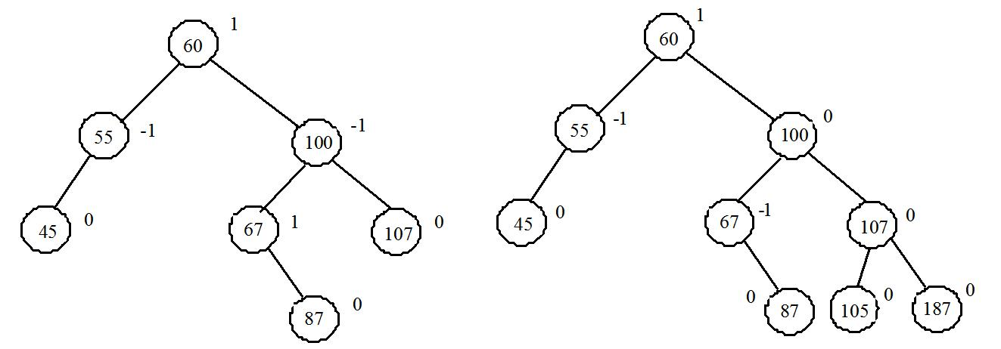

**3**. Describe LL rotation, RR rotation, LR rotation, and RL rotation for an AVL tree.

If a node is not balanced after an insertion or deletion operation, you need to rebalance it. The process of rebalancing a node is called a rotation. There are four possible rotations: LL, LR, RR, and RL.

An LL imbalance occurs at a node A such that A has a balance factor -2 and a left child B with a balance factor -1 or 0. This type of imbalance can be fixed by performing a single right rotation at A.

4. What are the data fields in the AVLTreeNode class?

AVLTreeNode inherits from TreeNode. The height is a new data field defined in AVLTreeNode. The data fields in TreeNode are left and right, pointing to the left and right subtree.

Hide Answer

**5.** True or false: AVLTreeNode is a subclass of TreeNode?

True

Hide Answer

**6**. True or false: AVLTree is a subclass of BST.

True

**7.** For the AVL tree in Figure 26.1a, show the new AVL tree after adding element 40. What rotation do you perform in order to rebalance the tree? Which node was unbalanced?

After inserting 40, node 55 is unbalanced, perform LL rotation. The resulting tree is

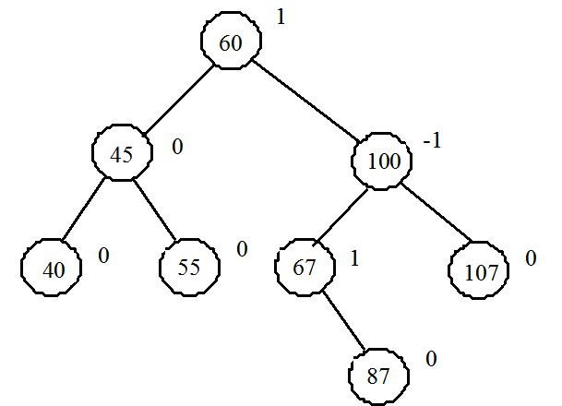

**8.** For the AVL tree in Figure 26.1a, show the new AVL tree after adding element 80. What rotation do you perform in order to rebalance the tree? Which node was unbalanced?

After inserting 80, node 67 is unbalanced, perform RL rotation. The resulting tree is

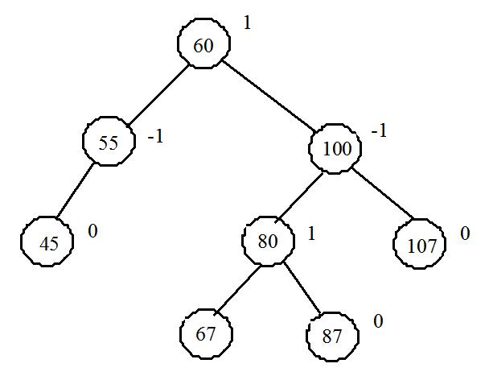

**9.** For the AVL tree in Figure 26.1a, show the new AVL tree after adding element 89. What rotation do you perform in order to rebalance the tree? Which node was unbalanced?

After inserting 89, node 67 is unbalanced, perform RR rotation. The resulting tree is

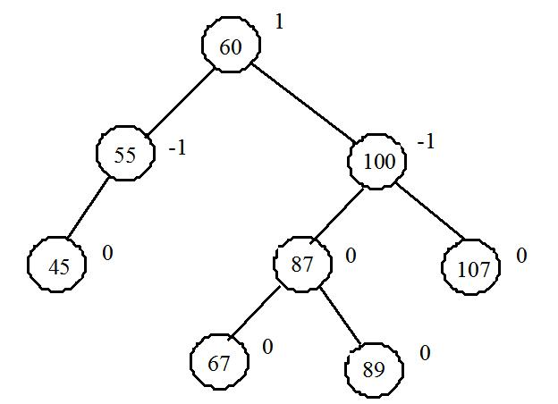

**10.** Use Listing 26.2 as a template to describe the algorithms for implementing the RR, LR, and RL rotations.

Here is the algorithm for hte LR rotation.

LR Rotation Algorithm

1. balanceLR(TreeNode A, TreeNode parentOfA) {
2. Let B be the left child of A.
3. Let B be the right child of B.

4

1. if (A is the root)
2. Let C be the new root
3. else {
4. if (A is a left child of parentOfA)
5. Let C be a left child of parentOfA;
6. else
7. Let C be a right child of parentOfA;
8. }

13

1. Make T3 the left subtree of A by assigning C.right to A.left;
2. Make T2 the right subtree of B by assigning C.left to B.right;
3. Make B the left child of C by assigning B to C.left;
4. Make A the right child of C by assigning A to C.right;

18

1. Update the height of node A, node B, and node C;
2. } // End of method

**11.** For the AVL tree in Figure 26.1a, show the new AVL tree after deleting element 107. What rotation do you perform in order to rebalance the tree? Which node was unbalanced?

After deleting 107, node 100 is unbalanced, perform LR rotation. The resulting tree is

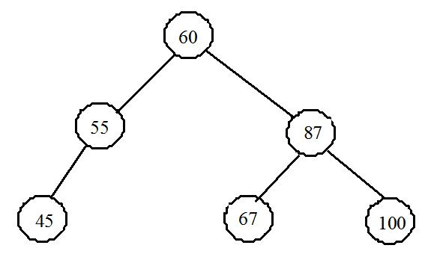

**12.** For the AVL tree in Figure 26.1a, show the new AVL tree after deleting element 60. What rotation do you perform in order to rebalance the tree? Which node was unbalanced?

After deleting 60, node 55 is unbalanced, perform RL rotation. The resulting tree is

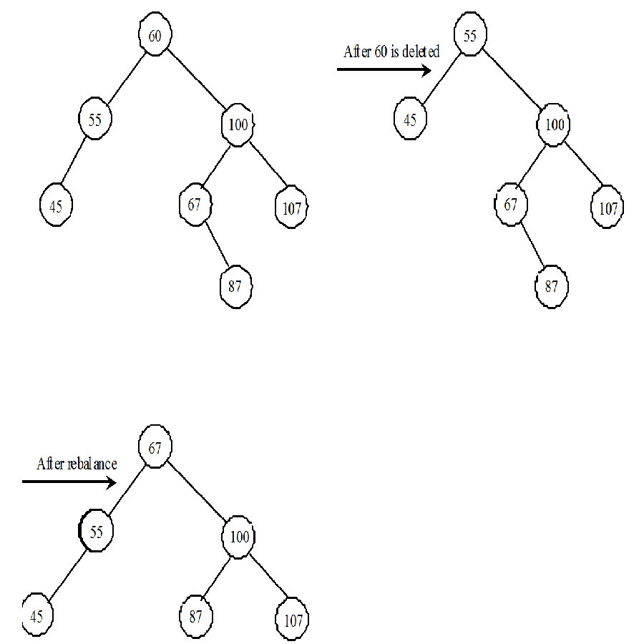

**13.** For the AVL tree in Figure 26.1a, show the new AVL tree after deleting element 55. What rotation did you perform in order to rebalance the tree? Which node was unbalanced?

After deleting 55, node 60 is unbalanced, perform LR rotation. The resulting tree is

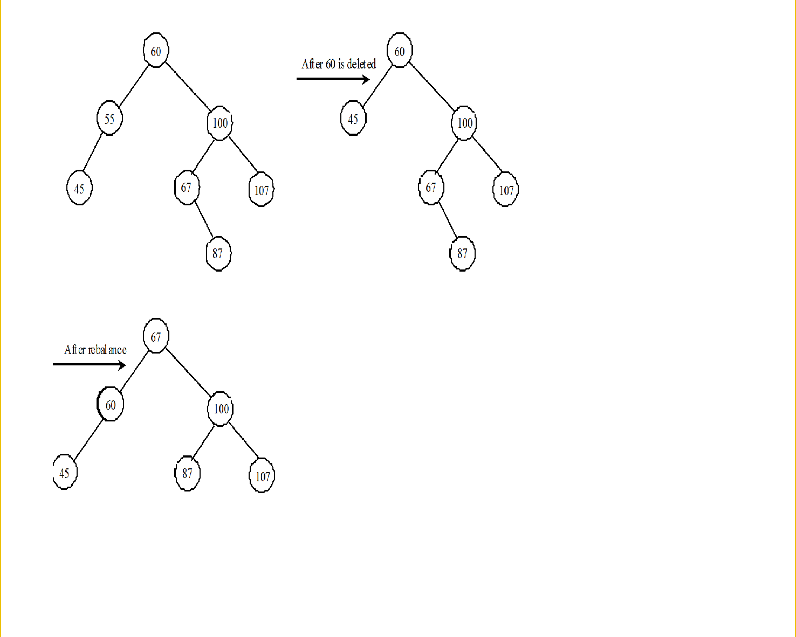

**14.** For the AVL tree in Figure 26.1b, show the new AVL tree after deleting elements 67 and 87. What rotation did you perform in order to rebalance the tree? Which node was unbalanced?

After deleting 67 and 87 in Figure 29.1b, node 100 is unbalanced, perform RR rotation. The resulting tree is

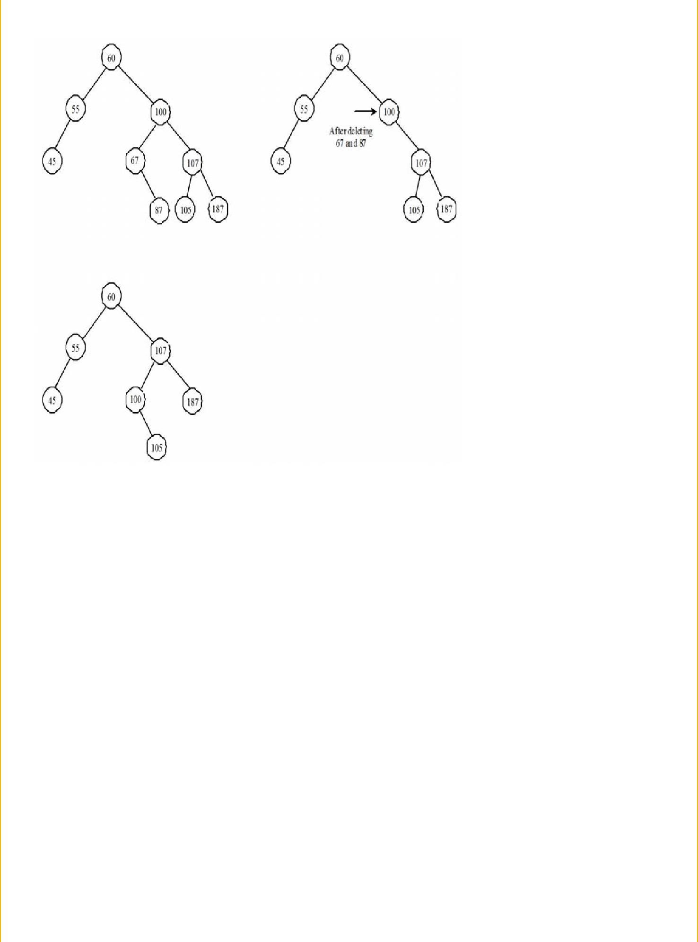

**15.** Why is the createNewNode method defined protected? When is it invoked?

In the BST class, the createNewNode() method creates a TreeNode object. This method is defined protected in BinaryTree. It is overridden in the AVLTree class to create an AVLTreeNode. It is invoked from the insert() method in the BST class.

Hide Answer

**16.**  When is the updateHeight method invoked? When is the balanceFactor method invoked? When is the balancePath method invoked? Will the program work if you replace the break in line 61 in the AVLTree class with return and add return at line 69?

updateHeight(AVLTreeNode<E>) is invoked to update the height of a node. It is invoked to rebalance the tree. balanceFactor is invoked to check the balance factor of a node. It is invoked when a path is rebalanced. balancePath is invoked along the path where a new node is inserted or a node is deleted.

Once an inbalanced node is fixed, all the nodes are balanced. There is no need to continue to check it along the paht from e to the root. So, using a return statement to exit the method is more efficient and correct. You can replace the break in line 61 in the AVLTree class with return and add return at line 69.

**17.** What are data fields in the AVLTree class?

All data fields defined in the BST class are inherited in the AVLTree class. The AVLTree class does not define new data fields.

**18.**  In the insert and delete methods, once you have performed a rotation to balance a node in the tree, is it possible that there are still unbalanced nodes?

No.

**19.** Show the change of an AVL tree when inserting 1, 2, 3, 4, 10, 9, 7, 5, 8, 6 into the tree, in this order.

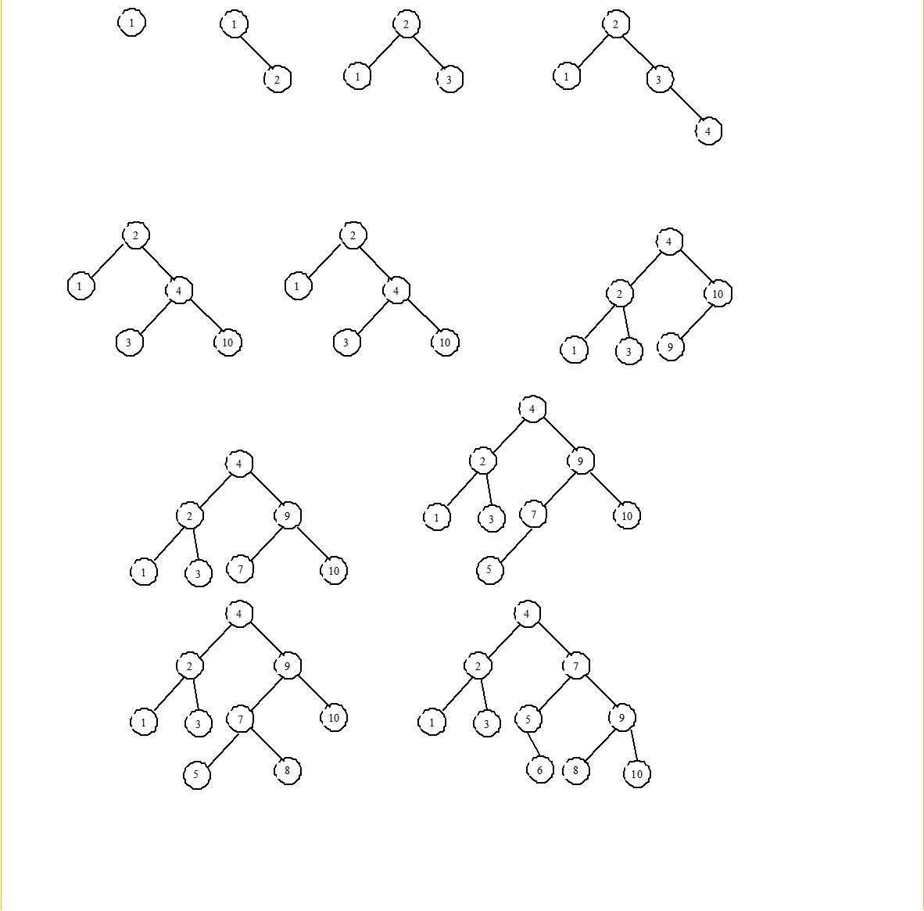

**20.** For the tree built in the preceding question, show its change after 1, 2, 3, 4, 10, 9, 7, 5, 8, 6 are deleted from the tree in this order.

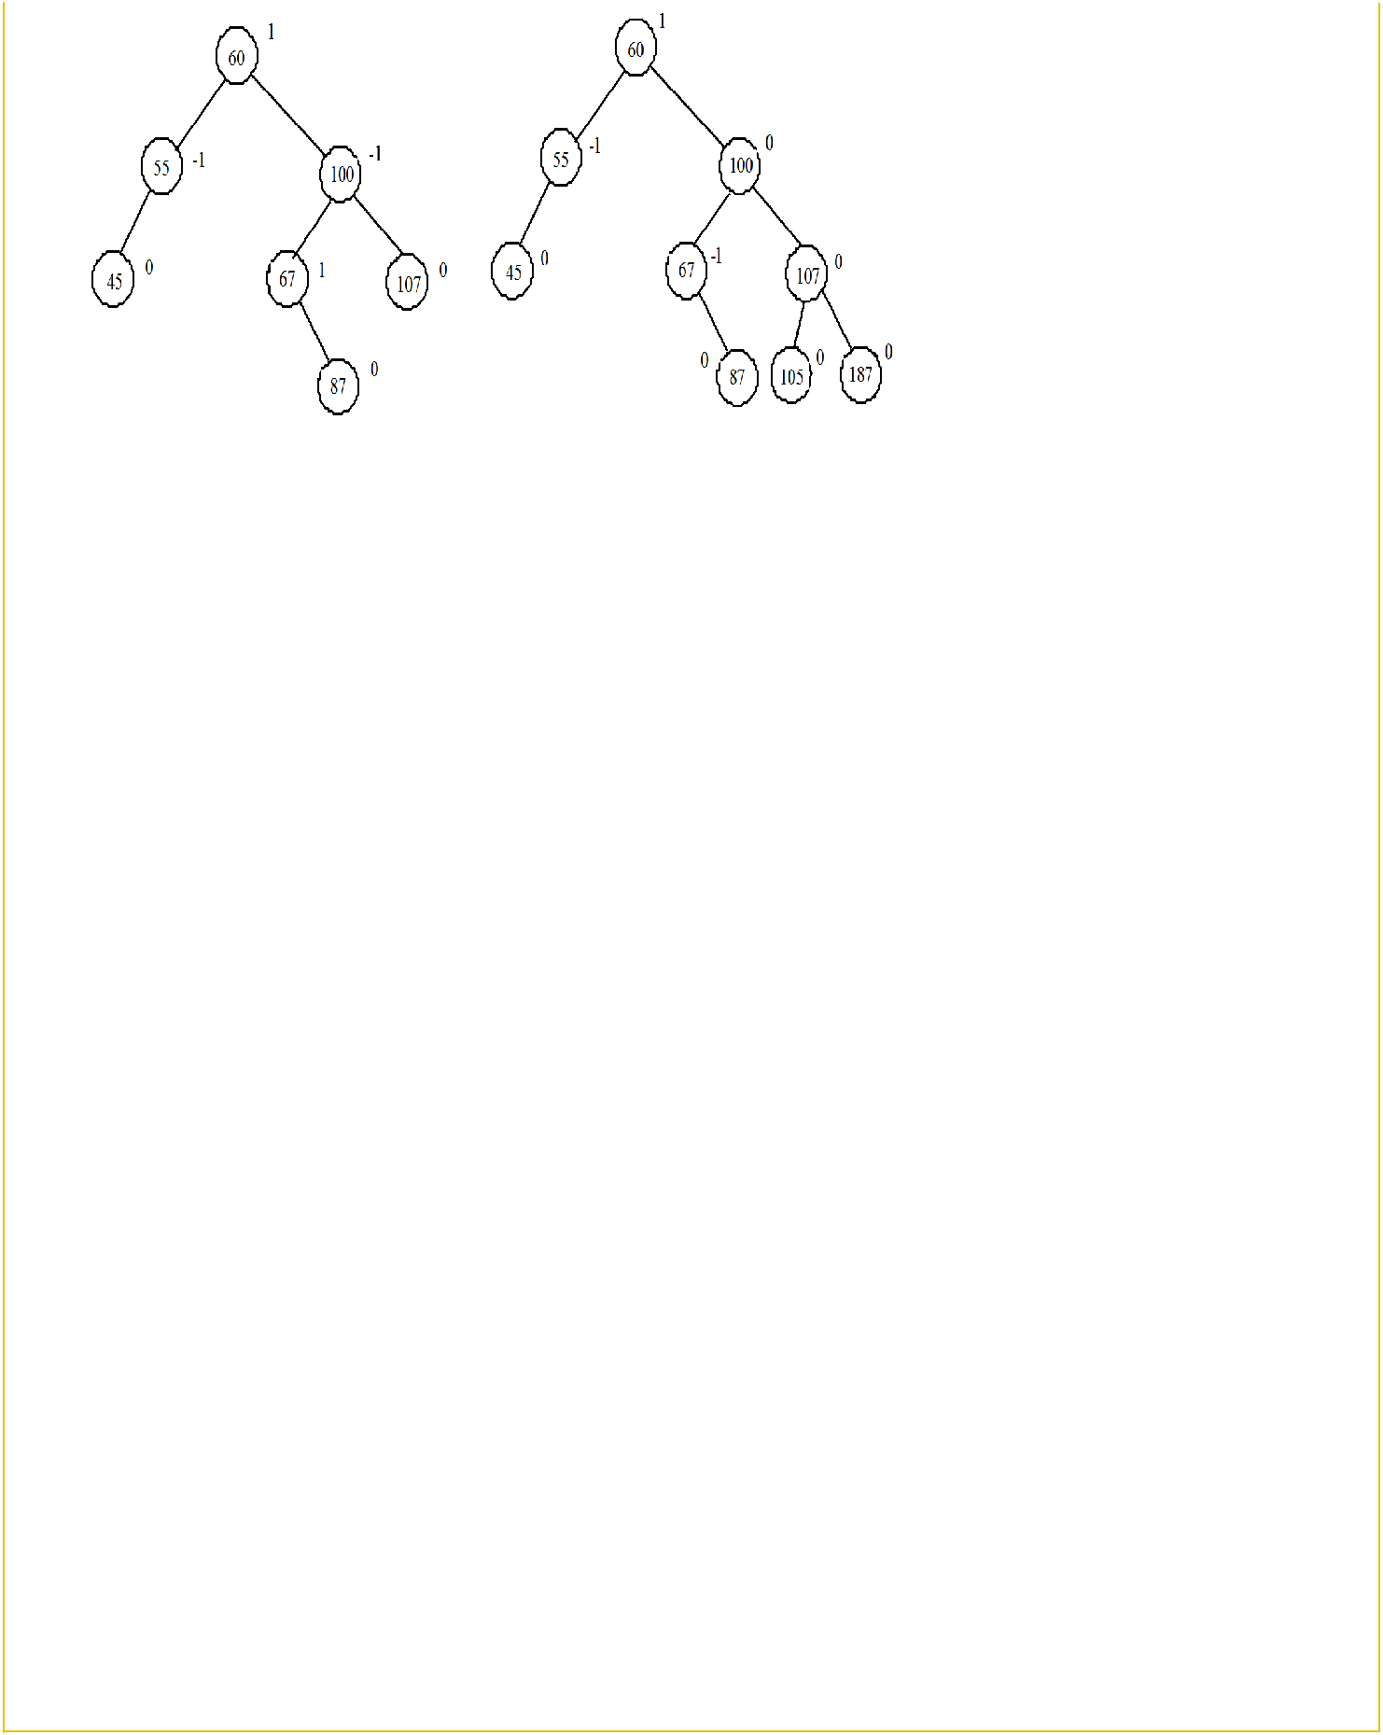

**21.** Can you traverse the elements in an AVL tree using a foreach loop?

Yes.

**22.** What is the maximum/minimum height for an AVL tree of 3 nodes, 5 nodes, and 7 nodes?

What is the maximum/minimum height for an AVL tree of 3 nodes is 2/2, for 5 nodes is 3/3, for 7 nodes is 4/3?

**23.** If an AVL tree has a height of 3, what maximum number of nodes can the tree have? What minimum number of nodes can the tree have?

If an AVL tree has a height of 3, what maximum number of nodes can the tree have? 7. What minimum number of nodes can the tree have? 4

**24.** If an AVL tree has a height of 4, what maximum number of nodes can the tree have? What minimum number of nodes can the tree have?

If an AVL tree has a height of 4, what maximum number of nodes can the tree have? 15. What minimum number of nodes can the tree have? 7